Finca Can Benito
Exclusive Retreat Oasis with Sea View in Ibiza
A place where time doesn’t matter.
Finca Can Benito is an exceptional retreat on Ibiza – created for people who value peace, privacy, and quality. Nestled in a protected natural landscape of pine trees and Mediterranean gardens, it offers expansive views across greenery all the way to the sea.
The stylish finca provides the ideal setting for up to 6 guests and combines authentic Ibizan architecture with timeless elegance. Bright spaces, clean lines, and a harmonious layout create an atmosphere of lightness, tranquility, and Mediterranean serenity.
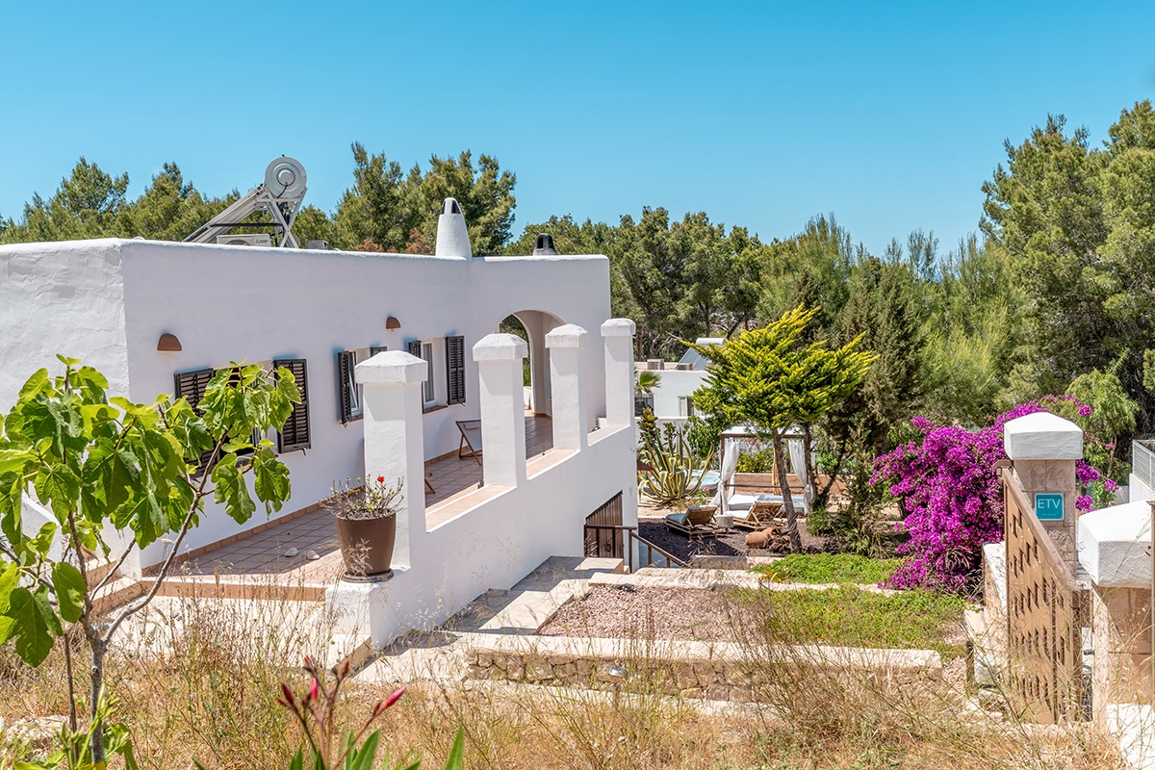
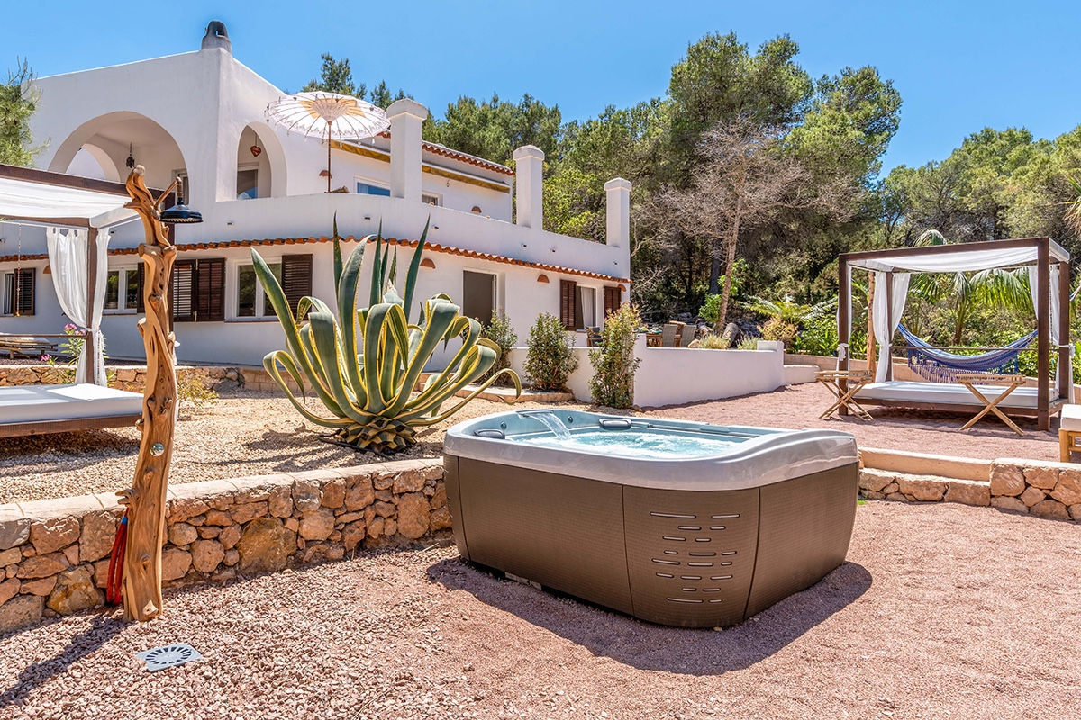

Living & Spatial Experience
The house extends over two floors with approx. 200 m² of living space. Two spacious living areas, three stylish bedrooms, and three bathrooms ensure comfort and privacy.

Outdoor & Lifestyle
Multiple terraces, lounge areas, a luxury whirlpool, and lush gardens create a perfect setting for relaxation—from sunny breakfasts to unforgettable sunsets.

Location
Located in a quiet and private area, yet only minutes from Ibiza’s most beautiful beaches like Cala Tarida, Cala Conta, and Cala Bassa.

Key Facts
• Max. guests: 6
• 3 bedrooms | 3 bathrooms
• Approx. 200 m² living space
• Multiple terraces & outdoor areas
• Luxury whirlpool
• Sea view & quiet location
Arrive. Breathe. Return.

Impressions
